**Global Climate Change:**

Earth’s climate has always been changing in its history. There were phases that earth’s climate became colder or warmer for long periods of time. Those periods of climate change have been related to changes on the earth in the past such as the end of ice age and the drying of the Sahara. Although those changes in earth’s climate can be considered as a natural phenomenon, the recent global warming can be related to human activities. An activity that can be related to the current change of the climate is the burning of fossil fuels. The increase of CO2 in the atmosphere together with the increase of other greenhouse gases can be consider as contributors to the recent global warming.

WHO supports that the Mediterranean region is particularly sensitive to climate change. The human health, the ecosystem, the economy and the expansion of existing problems of desertification, water scarcity and food production are the primary aspects that are threaten by increasing temperature and reduced precipitation in the Mediterranean region ([[1]](http://www.euro.who.int/en/what-we-do/health-topics/environment-and-health/Climate-change/activities/climate-change-and-impacts-research-the-mediterranean-environment-the-circe-project)).

Climate change has several effects on communities all over the world. Few important effects are summarized in this report. Modification of vector which is related to infectious diseases in tropical and subtropical regions is one of them. Another one is the quality and availability of water, which will have an important impact on public health. Air quality can be reduced due to climate change giving rise to infectious diseases. Human migration can be an important factor for the spread and boost of infectious diseases within a community.

The aim of this paper is to discuss the possible infectious diseases that may affect public health due to climate change at the Eastern Mediterranean region. I shall deal with this topic using hypothetical terms, since I cannot know for sure that an increase in temperature or rainfall patterns will have certain effects in the future. However, it is feasible to review literature and report favorable conditions that certain infectious diseases occurred based on climate trends and history of Eastern Mediterranean region.

**Background information:**

Cyprus can be considered as having a Mediterranean climate with typical seasonal rhythm. Hot dry summers exist from June to September and winters from November to March. Spring seasons are considered short in Cyprus as they present in April and May. Autumn seasons also consider short as they presented in October. The temperature in summer is high and the skies are usually cloudless. Rainfall in summer is very low as only isolated thunderstorms can occur sometimes. On the other hand the most of the annual precipitation is resulted in winters from small depressions that cross the Mediterranean Sea, but last usually for one day ([[2]](http://www.tau.ac.il/~pinhas/papers/1999/Price_et_al_AR_1999.pdf)).

The maximum and minimum temperatures may increase in Cyprus annually by 1.5 $℃$. The precipitation may decrease by an average 7% annually on the mainland and 2% to the mountains. Another effect is the increase of the summer days for a minimum of two weeks and tropical nights for one month. Also the dry days in Limassol may increase by nine days. Those changes will influence the Cyprus ecosystems society and economical activities the next decades ([[3]](http://www.springerlink.com.ezp-prod1.hul.harvard.edu/content/772536n63q500wpt/fulltext.pdf)).

**Vector – borne infectious diseases:**

Malaria existed many years ago in Cyprus. A study undertaken was examined children 3 or 4 years old and 15 years old for splenic enlargement. Generally spleen rates of 5% or 10% are considered to be low. In some cases in Cyprus the spleen rate reached the 100%. In Famagusta the spleen rate identified from 20% and over. That might be caused by leakages or to the wells that were located there. The irrigation tanks that were located in the area did not had large numbers of Anophelines, but in other season that the water level might be lower the Anophelines could be easier to be found. A large number of Anophelines were found in a place where the water escaped and in a village located nearby the spleen rate among children was 100% [([4])](http://www.ncbi.nlm.nih.gov.ezp-prod1.hul.harvard.edu/pmc/articles/PMC2002954/pdf/procrsmed00949-0111.pdf).

An outbreak of Leishmaniasis existed in Cyprus which it was reported as the first autochthonous case of L. donovani in Europe. L. tropica needs P. sergenti which is found in several places in southern Europe within them the Cyprus. As it can be seen in the Figure 1 below Cyprus was within the disease endemic region with high human visceral leishmaniasis and low levels of cutaneous leismaniasis [([5])](http://wwwnc.cdc.gov/eid/article/14/7/pdfs/07-1589.pdf).

**Figure 1:**



Change in climate may favor vector borne diseases in areas were previously did not exist. For instance, evidence indicates that habitats favorable to malaria vectors rise at climate with increased temperature and rainfall. Additionally, habitats for Phlrbotomus sp. the vectors for the leishmaniases are favorable under climate with increased temperature but reduced rainfall [([6])](http://www.ncbi.nlm.nih.gov/pmc/articles/PMC1293729/pdf/jrsocmed00105-0048.pdf).

Vector-borne diseases occurrence is influenced by both, vector and host factors. Vector factors include the size of the population, the proportion of vectors carrying disease, the rate of biting, the availability for intermediate host and the ability of the vector to survive the disease. Few more vector factors include the mortality rate of the vector, how efficient is the transmission of the disease through the arthropod bite and how sustainable and renewable is the infected vector population. On the other hand, the host factors include the size of host population, susceptibility of the existing hosts, the migration and the formation of the new hosts and the extend of which the hosts enters the vector environment. Additionally, the mortality rate that is caused by the disease, the potential for extended immunity, the availability and efficiency of vector control measures and the availability of disease control measures are few more host factors [([7])](http://ac.els-cdn.com.ezp-prod1.hul.harvard.edu/S0188440905001517/1-s2.0-S0188440905001517-main.pdf?_tid=a06b90f3ca18dbc5e48b72b895f673e2&acdnat=1340811344_4de8c3870a5849dc932b820a6df8148c).

Climate can influence the transmission of Malaria. In warm and moist climates the mosquitos can survive and transmit Malaria and in climates that mosquitos cannot survive transmission does not occur. The ideal conditions for the transmission of Malaria are the high humidity and temperatures between 20oC to 30oC. Global warming can provide conditions that are favorable for the transmission of Malaria. That is because temperature can influence the lifespan of a mosquito and as a result the number of times that an infected mosquito will bite the host [(7)](http://ac.els-cdn.com.ezp-prod1.hul.harvard.edu/S0188440905001517/1-s2.0-S0188440905001517-main.pdf?_tid=a06b90f3ca18dbc5e48b72b895f673e2&acdnat=1340811344_4de8c3870a5849dc932b820a6df8148c).

**Waterborne infectious diseases**

In 2008 Cyprus experienced drought and in the particular year the rainfall was lower by 45% in comparison to the years 2000 to 2007. That significant reduction on rainfall caused the reservoirs to fill only at 3% capacity. That created the need for the Government of Cyprus to import water from Greece [(3)](http://www.springerlink.com.ezp-prod1.hul.harvard.edu/content/772536n63q500wpt/fulltext.pdf).

The quality and quantity of the water supply is associates either directly or indirectly with infectious diseases. Escherichia coli, Vibrio cholera, Salmonella sp., hepatitis A and E (HAV and HEV), poliomyelitis, Giardia lamblia and Entamoeba histolytica are organisms directly transmitted by contaminated water or contaminated food that was prepared by contaminated water. Insufficient water also favors the transmission of infectious diseases due to inadequate hand-washing and personal hygiene. Infectious diseases such as Shigella sp., A.lumbricoides, Trichuris trichiura and Enterobius verrmicularis are likely to increase. Known epidemics such as cholera plague and typhus previously existed in the temperature zone, so they may return [(6)](http://www.ncbi.nlm.nih.gov/pmc/articles/PMC1293729/pdf/jrsocmed00105-0048.pdf). However, excess rainfall and flooding can contribute to the rise of infectious diseases. One possible factor can be due to runoff from overwhelmed sewage lines or due to contamination of water from livestock [([8])](http://www.nejm.org/doi/pdf/10.1056/NEJMp0912931).

**Foodborne infectious diseases**

Climate change can affect food safety through four main elements of food security, in particular, availability, stability, utilization and access. All these three elements can be affected by climate change [([9])](http://www.pnas.org.ezp-prod1.hul.harvard.edu/content/104/50/19703.full.pdf).

Rainfall patterns will affect agricultural practices including irrigation, cropping patterns, livestock husbandry and fertilizer/pesticide application. Therefore, changes in irrigation practices will affect the distribution of malaria and schistosomiasis [(6)](http://www.ncbi.nlm.nih.gov/pmc/articles/PMC1293729/pdf/jrsocmed00105-0048.pdf).

In Cyprus there were two outbreaks of bluetongue disease before, the first outbreak occurred in 1969 and the second in 1977. In the August of 1977 the outbreak begun simultaneously in the Famagusta and Kyrenia district. Both districts are located at the Turkish occupied area of Cyprus [([10])](http://www.ncbi.nlm.nih.gov.ezp-prod1.hul.harvard.edu/pmc/articles/PMC2130172/pdf/jhyg00045-0159.pdf).

Evidence indicates that climate change can increase the outbreak of bluetongue in areas of Europe. Additionally, change in agricultural ecosystems can change disease dynamics. The spread of foodborne pathogens such us, Cryptosporidium parvum, diarrheagenic Escherichia coli, Listeria monocytogenes and Campylobacter jejuni have been associated with intensive farming systems [([11])](http://www.pnas.org.ezp-prod1.hul.harvard.edu/content/early/2011/05/10/1012953108.full.pdf).

**Infectious diseases due to reduced air quality**

Air quality in Cyprus may get worse due to climate change. Warm, dry and stagnant conditions are expected to deteriorate the air quality since it will be much harder to remove air pollutants [(3)](http://www.springerlink.com.ezp-prod1.hul.harvard.edu/content/772536n63q500wpt/fulltext.pdf). Hot summers will increase the need for air conditioning and therefore the use of electricity.

The level of humidity in Cyprus is affected at coastal areas due to the distance from the sea. The average humidity reported in Cyprus during winter period range from 65% to 95%. Lower levels were reported during the summer months at midday which range from 15% to 30%. Additionally, the average maximum air temperature of Cyprus range from 36% to 27% for the months July and August respectively [([12])](http://www.moa.gov.cy/moa/MS/MS.nsf/DMLcyclimate_en/DMLcyclimate_en?OpenDocument). As mentioned above relative humidity and air temperature are likely to rise due to climate change. That gives some concern for the prevalence of infectious diseases since such conditions increase the prevalence of infectious diseases.

Further increase in temperature will increase ozone levels especially in urban areas. That will contribute to the increase of respiratory diseases like asthma and it will trigger the health of cardiac and pulmonary disease patients [([13])](http://cahpf.org/GoDocUserFiles/553.12_NRDC_Global_Warming_and_Our_Health.pdf).

Recent research on behalf of Environmental Protection Agency (EPA) supports that Legionnaires diseases can be associated with climate change. Some key factor that can influence the development of legionnaires disease due to climate change can be warm and humid weather with rainfall, warm summer months, natural or man-made waters range from 85 to 110 $℉$ can facilitate rapid growth of Legionella [([14])](http://www.epa.gov/iaq/pdfs/climate_and_microbial_iaq.pdf).

**Human migration**

The population of Cyprus increases day by day due to the large number of foreign workers coming into the island legally or illegally and the growing of Cypriot population. The urban population also increases due to the move of rural population to the urban areas of Cyprus. The population of Limassol increase dramatically through the years. The Limassol population was 8000, 153,000 [(2)](http://www.tau.ac.il/~pinhas/papers/1999/Price_et_al_AR_1999.pdf) and 230.800 [([15])](http://www.mof.gov.cy/mof/cystat/statistics.nsf/All/BC00ECA1F219DF78C22577CB0039BF65?OpenDocument&sub=1&sel=1&e=&print) respectively for the years 1900, 1996 and 2009.

Possible climate change effects on Limassol such as droughts that will result on decrease of crop yield, increase in pests, loss of fertile land due to rise of sea level and increase of soil salinity and erosion. An increase in UVB radiation will result in decrease of marine food due to the effect of UV-B radiation on nitrogen – fixation in phytoplankton and warming of sea [(6)](http://www.ncbi.nlm.nih.gov/pmc/articles/PMC1293729/pdf/jrsocmed00105-0048.pdf).

Overcrowding in combination with undernutrition, poor access to health care and rapid uncontrolled urbanization due to climatic change might increase the prevalence of infectious diseases, such as tuberculosis, leprosy, skin infections, measles and other childhood infections, ectoparasitic infections and probably plague [(6)](http://www.ncbi.nlm.nih.gov/pmc/articles/PMC1293729/pdf/jrsocmed00105-0048.pdf). Additionally, possible rise of sea level will result to move that huge number of population away from the coastal areas. Additionally human migration can increase the incidence of vector – borne diseases. Specifically, infected persons that may come to a non-infected region (Cyprus for example) can infect uninfected mosquitoes and therefore non-immune host will be exposed to newly infected mosquitos [(7)](http://ac.els-cdn.com.ezp-prod1.hul.harvard.edu/S0188440905001517/1-s2.0-S0188440905001517-main.pdf?_tid=a06b90f3ca18dbc5e48b72b895f673e2&acdnat=1340811344_4de8c3870a5849dc932b820a6df8148c).

In Limassol is located the major port of the island of Cyprus. In the Limassol port arrive daily food from different corners of the world, cargo, transported animals and tourists. Those arrivals are important sources of infectious diseases in the island and specifically in the coastal area of Limassol (seen in the figure 2).

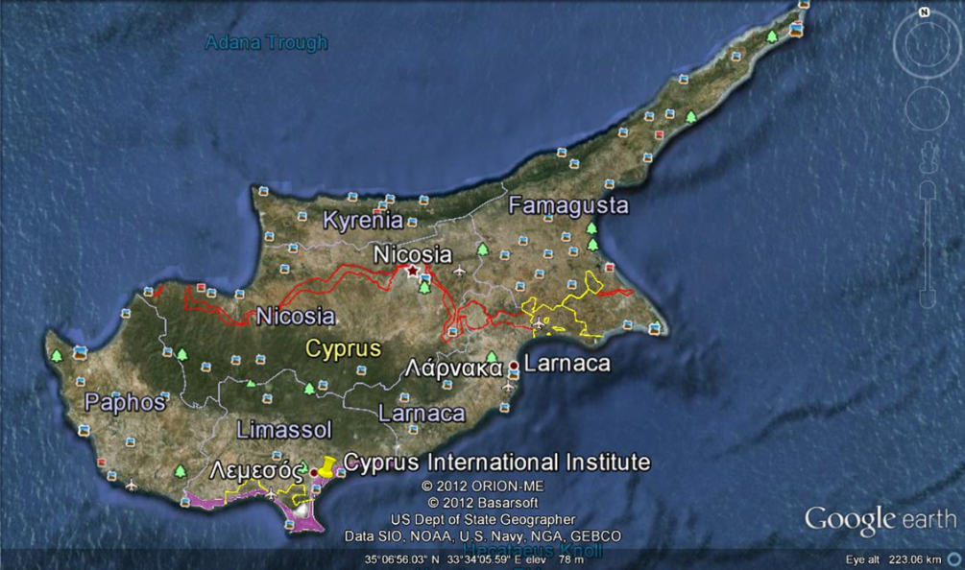**Figure 2**:

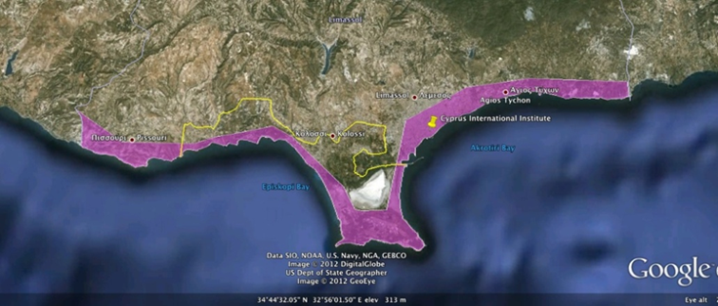

**Conclusion**

This report provides basic information on the current climate status of the Eastern Mediterranean region and specifically of Cyprus and projected information on the future climate conditions of Cyprus as projected. These information were combined with the knowledge of how vector-borne, food-borne, water-borne and air-borne infectious diseases can be result as endemics in Limassol district. The human migration is also taken into consideration as an important factor for the spread of infectious diseases. Based on the findings of the report it would be wise for the Cyprus Government and every single country located in the Eastern Mediterranean region to develop policy regarding climate change. Government should conduct ecological, laboratory studies and research on controls for vectors in order to be able to avoid the worst case scenarios from happening.

**Bibliography**

1. Worlds Health Organization [WHO], (2012), Climate change. Available at: <http://www.euro.who.int/en/what-we-do/health-topics/environment-and-health/Climate-change/activities/climate-change-and-impacts-research-the-mediterranean-environment-the-circe-project>
2. Price, C., Michaelides, S., Pashiardis, S., Alpert, P., (1999), Long term changes in diurnal temperature range in Cyprus. Atmospheric Research 51: 85 – 98. Available at: <http://www.tau.ac.il/~pinhas/papers/1999/Price_et_al_AR_1999.pdf>
3. Hadjinicolaou, P., Giannakoppoulos, C., Zeferos, C., Lange, M.A., Pashiardis, S., Levieveld, J., (2010), Mid-21st century climate and weather extremes in Cyprus as projected by six regional climate models. Reg Environmen Change 11: 441 – 457. Available at: <http://www.springerlink.com.ezp-prod1.hul.harvard.edu/content/772536n63q500wpt/fulltext.pdf>
4. Ronald, R., (1914), Malaria in Cyprus and Greece. Section of Epidemiology and State Medicine, 107 – 118. Available at: <http://www.ncbi.nlm.nih.gov.ezp-prod1.hul.harvard.edu/pmc/articles/PMC2002954/pdf/procrsmed00949-0111.pdf>
5. Dujardin, J.C., Campino, L., Canavate, C., Dedet, J.P., Gradoni, L., Soteriadou, K., Mazeris, A., Ozbe, Y., Boelaert, M., (2008). Spread of vector-borne diseases and neglect of Leishmaniasis, Europe. Emerging Infectious Diseases, 14: 1013 – 1018. Available at: <http://wwwnc.cdc.gov/eid/article/14/7/pdfs/07-1589.pdf>
6. Cook, G C. (1992), Effect of global warming on the distribution of parasitic. Journal of the Royal Society of Medicine, 85: 688 – 691. Available at: <http://www.ncbi.nlm.nih.gov/pmc/articles/PMC1293729/pdf/jrsocmed00105-0048.pdf>
7. Khasnis, A.A., Nettleman, M.D., (2005), Global warming and infectious disease. Archives of Medicine Research, 36: 689 – 696. Available at: <http://ac.els-cdn.com.ezp-prod1.hul.harvard.edu/S0188440905001517/1-s2.0-S0188440905001517-main.pdf?_tid=a06b90f3ca18dbc5e48b72b895f673e2&acdnat=1340811344_4de8c3870a5849dc932b820a6df8148c>
8. Shuman, E., (2010), Global climate change and infectious diseases. The New England Journal of Medicine 362: 1061 – 1063. Available at: <http://www.nejm.org/doi/pdf/10.1056/NEJMp0912931>
9. Schmidhuber, J., Tubiello, F., (2007), Global food security under climate change. National Academy of Science of the USA, 104: 19703 – 19708. Available at: <http://www.pnas.org.ezp-prod1.hul.harvard.edu/content/104/50/19703.full.pdf>
10. Sellers, R.F., Gibbs, E.P.J., Herniman, K.A.J., (1979), Possible origin of the bluetongue in Cyprus August 1977. J. Hyg., Camb. 83: 547 – 555. Available at: <http://www.ncbi.nlm.nih.gov.ezp-prod1.hul.harvard.edu/pmc/articles/PMC2130172/pdf/jhyg00045-0159.pdf>
11. Perry, B.D., Grace, D., Sones, K., (2010), Current drivers and future directions of global livestock disease dynamics. PNAS: 1 – 7. Available at: <http://www.pnas.org.ezp-prod1.hul.harvard.edu/content/early/2011/05/10/1012953108.full.pdf>
12. Meteorological Service, (2012), The climate of Cyprus. Available at: <http://www.moa.gov.cy/moa/MS/MS.nsf/DMLcyclimate_en/DMLcyclimate_en?OpenDocument>
13. NRDC, Global warming and our health: Addressing the most serious impacts of climate change. Available at: <http://cahpf.org/GoDocUserFiles/553.12_NRDC_Global_Warming_and_Our_Health.pdf>
14. Morey, P.R., (2010), Climate change and potential effects on microbial air quality in the built environment. Available at: <http://www.epa.gov/iaq/pdfs/climate_and_microbial_iaq.pdf>
15. Statistical Service of the Republic of Cyprus, (2010), Latest Figures: Population and Demographic Statistics, 2009. Available at: <http://www.mof.gov.cy/mof/cystat/statistics.nsf/All/BC00ECA1F219DF78C22577CB0039BF65?OpenDocument&sub=1&sel=1&e=&print>
16. Statistical Service of the Republic of Cyprus, (2010), Latest Figures: Population and Demographic Statistics, 2009. Available at: <http://www.mof.gov.cy/mof/cystat/statistics.nsf/All/BC00ECA1F219DF78C22577CB0039BF65?OpenDocument&sub=1&sel=1&e=&print>

1. Worlds Health Organization [WHO], (2012), Climate change.
2. Price, C., Michaelides, S., Pashiardis, S., Alpert, P., (1999), Long term changes in diurnal temperature range in Cyprus. Atmospheric Research 51: 85 – 98.
3. Hadjinicolaou, P., Giannakoppoulos, C., Zeferos, C., Lange, M.A., Pashiardis, S., Levieveld, J., (2010), Mid-21st century climate and weather extremes in Cyprus as projected by six regional climate models. Reg Environmen Change 11: 441 – 457.
4. Ronald, R., (1914), Malaria in Cyprus and Greece. Section of Epidemiology and State Medicine, 107 – 118.
5. Dujardin, J.C., Campino, L., Canavate, C., Dedet, J.P., Gradoni, L., Soteriadou, K., Mazeris, A., Ozbe, Y., Boelaert, M., (2008). Spread of vector-borne diseases and neglect of Leishmaniasis, Europe. Emerging Infectious Diseases, 14: 1013 – 1018.
6. Cook, G C. (1992), Effect of global warming on the distribution of parasitic. Journal of the Royal Society of Medicine, 85: 688 – 691.
7. Khasnis, A.A., Nettleman, M.D., (2005), Global warming and infectious disease. Archives of Medicine Research, 36: 689 – 696.
8. Shuman, E., (2010), Global climate change and infectious diseases. The New England Journal of Medicine 362: 1061 – 1063.
9. Schmidhuber, J., Tubiello, F., (2007), Global food security under climate change. National Academy of Science of the USA, 104: 19703 – 19708.
10. Sellers, R.F., Gibbs, E.P.J., Herniman, K.A.J., (1979). Possible origin of the bluetongue in Cyprus August 1977. J. Hyg., Camb. 83: 547 – 555.

   
11. Perry, B.D., Grace, D., Sones, K., (2010), Current drivers and future directions of global livestock disease dynamics. PNAS: 1 – 7.
12. Meteorological Service, (2012). The climate of Cyprus.
13. NRDC, Global warming and our health: Addressing the most serious impacts of climate change.
14. Morey, P.R., (2010), Climate change and potential effects on microbial air quality in the built environment.
15. Statistical Service of the Republic of Cyprus, (2010), Latest Figures: Population and Demographic Statistics, 2009.